The Pima–Maricopa Villages During the Mexican Era, 1821-1846
Pima-Maricopa Irrigation Project Education Initiative
2003-2004

Restoring water to ensure the
continuity of the Akimel O’otham
and Pee Posh tradition of agriculture

Re

The growing political crisis in Spain and on the northern colonial frontier of New Spain interrupted both the religious and economic objectives of the Crown. Political infighting and Napoleonic events in Europe forced Spain to turn its attention to more pressing matters at home. In the closing decades of the 18th century disputes over the limited water supplies in the Santa Cruz Valley north of Tucson surfaced. By the beginning of the 19th century, political bickering between the church and military (which was blamed for inciting Apache raids) added to the growing crisis.
Part 48

These crises ended any hope Spain had of establishing a mission and/or a presidio along the middle Gila River, much to the disappointment of the Pimas. Nonetheless, the Pima continued to peaceably cultivate the soil, a characteristic well publicized by Spanish missionaries and explorers. Focused on events in Spain, the Crown was also unable to stop the mounting Mexican cry for independence. In September of 1821, Mexico became independent of Spanish rule.
Mexican independence had little impact on the Pima and Maricopa. While Spain never conferred citizenship on the Indians, the Mexican constitution did, no longer recognizing colonial social distinctions. This meant the legal status of Indian was not recognized. Distant from the center of Mexican administration—both in Mexico City and Hermosillo—the social experiment had no real impact on the Pimas or Maricopas. The secularization of the Catholic Church and the expulsion of all foreign-born priests, however, did, leaving the Pimeria Alta with a limited Catholic influence.
In 1823, a Dominican priest named Felix Caballero left Baja California to journey to Sonora. Traveling up the Gila River through both Maricopa and Pima country, the Dominican priest arrived in Tucson renewing interest in an overland road to California. In June of that same year, Caballero was accompanied by Captain Jose Romero, commander of the Mexican garrison at Tucson, and headed north to the Gila River on a return trip to Baja California. Caballero passed through the Pima-Maricopa villages, finding the Maricopa now living just west of Maricopa Wells in Standing Bone Village.
Mariano de Urrea, governor of Sonora, praised the Pimas and their wheat, corn, bean and cotton fields. These crops were irrigated “by a canal, filled by means of a dam made of posts, with the flood waters the river carries to them each year.” In 1825, Urrea was replaced as Governor but Mexican officials worked to maintain good relations with both the Pimas and Maricopas.
At the same time, Mexican independence led to the arrival of the Milgahn or Americans in Pima country. While prohibited from entering the country under Spanish rule, Mexican laws were relaxed, with hundreds of American mountain men (or beaver trappers) descending the Gila River and its tributaries. The arrival of James Ohio Pattie on the Gila, in the winter of 1825-1826, initiated a stampede of trappers to the region, including Old Bill Williams, Pauline Weaver and Ceran St. Vrain.
The arrival of the trappers did not go unnoticed by either the Pima and Maricopa or the Mexicans. To combat the number of illegal trappers in Mexico, all frontier presidios—including Tucson—were ordered to provide detailed reports on the activities of such foreigners beginning in the spring of 1826. When Williams and St. Vrain passed through the villages in October 1826, Pima chief Antonio Culo Azul requested the party show proper identification or proceed to Tucson to report their activity. Finding the Americans friendly and open to trade, the Pimas—not willing to let such an opportunity slip by—initiated a brisk business of trade. At the same time, in another demonstration of their fidelity, Azul sent word of the trappers’ arrival to the presidio commander in Tucson. Passing through the Maricopa villages several days later, the trappers reveled in four days of gift exchanges and trade with the Maricopa.
Relations between the Pima-Maricopa and the mountain men were not always friendly. On at least one occasion, the Pima and Maricopa attacked the trappers because of their immoral activities. A retaliatory attack by the mountain men resulted in the death of several Pima and Maricopa men and brought about a truce. There were no other reports of any other troubles between the trappers and the Pima and Maricopa villagers. When Ewing Young led a company of trappers down the Gila River and through the Pima villages, in 1831, he was received with friendship and hospitality.
While continuing to trade with Mexican towns to the south (and through the annual trade fair on the Gila River), both the Pima and Maricopa recognized the benefits afforded them by the opportunities to trade with the Americans passing through their villages. While there is little record of trapping on the Gila River after 1827, trappers and explorers continued to follow the river west to California. The Pima and Maricopa, having been exposed to new trade partners, engaged in commerce with all who descended the river.
The Pimas also continued to grow “bountiful crops of wheat, corn, squashes, pumpkins and watermelons.” While cotton was grown in the Santa Cruz Valley, the Gila Pima “produced much more.” Trade with villages to the south continued, although by 1840 the Pima were seldom visited by Americans except those who “in distress” visited the villages, where they were “generously furnished horses and food.” When Apache raids resulted in the abandonment of “many of the fertile fields” at San Xavier, the Pimas increased production. Pima food crops were becoming more important to the Mexican and Indian population in the Santa Cruz Valley south of Tucson.
By the closing years of the Mexican era, few Americans made their way to the Pima-Maricopa villages. The Pima and their new neighbors the Maricopa continued to industriously till the land. Other than an occasional traveler, the Pima and Maricopa were for the most part isolated from outside contact. The advent of the Mexican War, in 1846, would end this isolation.
Beaver in the Gila River?
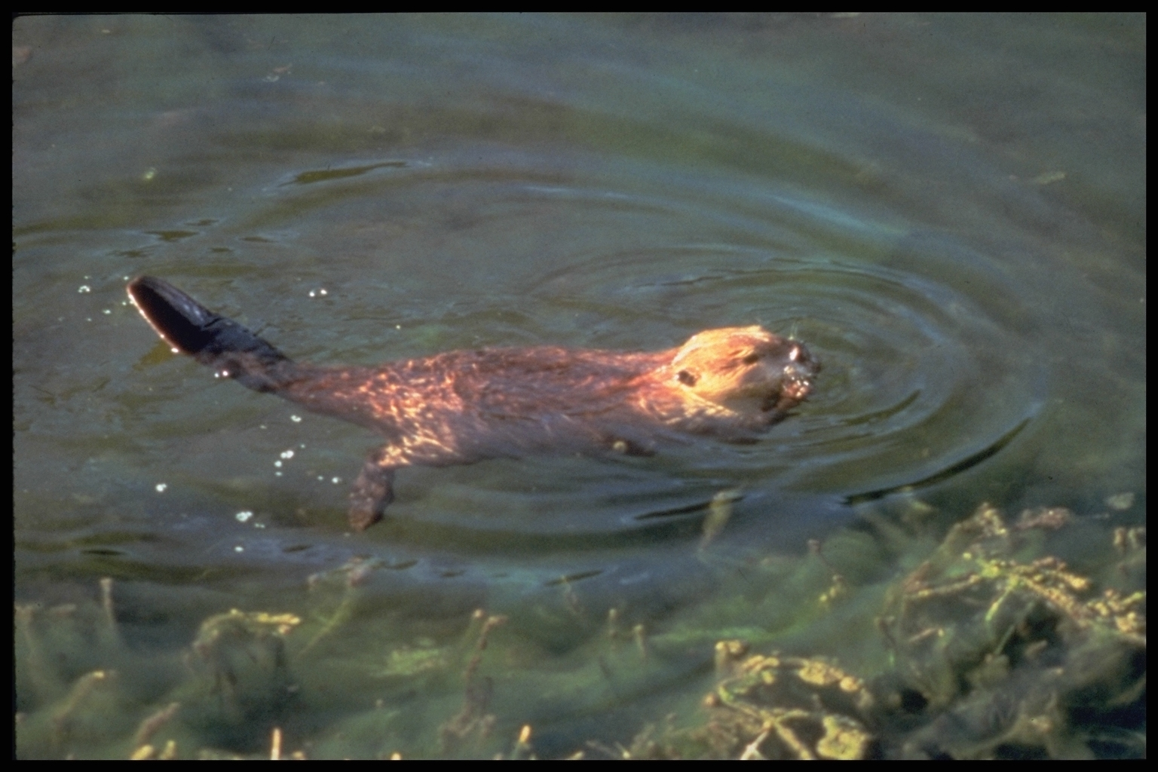
The Gila River was once home to millions of beaver, an important rodent that helps maintain wetlands and riparian areas. The beaver were also once considered an important source of food to the Pimas. In the 1820s, American mountain men entered the Gila River Valley and began trapping the beaver for their pelts (which were used to make felt hats in Europe). In less than ten years, most beaver were gone from the river.
Beavers (castor canadensis) are considered the “engineers” of the animal kingdom. Their immense power and skilled movements make it possible for them to down large trees. They are the largest rodents in all of North America. Adults are often four feet long and can weigh up to 60 pounds. The beaver's front teeth never stop growing. Their “buck toothed” appearance aids in gnawing at bark. Behind the front teeth lays a special flap of skin that keeps the beaver from getting a mouth full of water as he chews underwater. The beaver also has similar unique flaps of skin valves that prohibit the nose and ear canals from filling with water.
Did YOU know?
A beaver can gnaw through a 6 inch diameter tree in less than ten minutes using its powerful front teeth?

Beavers are paired for life. A baby beaver is called a kit and there are usually 4 or 5 kits born at one time.

A beaver has 4 front teeth that grow continuously. Cutting down trees helps the beaver to balance the growth rate of its teeth.

The average beaver can eat as much as 3 pounds of bark, twigs, branches and roots in one meal.

The ability of beavers to build dams often results in flooding of lowlands along the river.
Teacher Plan for “The Pima-Maricopa Villages During the Mexican Era”
Objectives

Students will be able to:

- Explain what citizenship means and discuss what Mexican citizenship meant for the Pima and Maricopa.

- Identify some facts about beavers and describe their importance to a particular ecosystem.
Terms to know and understand

- Napoleon
- Bickering
- Citizenship
- Secularization
- Expulsion
- Stampede
Critical Thinking:

- The Mexican Constitution provided citizenship for all the people living in Mexico, including the Indians. Spain had never conferred citizenship on the Indians of New Spain. Given the fact that the Pima and Maricopa were now considered citizens of Mexico, where do you think their loyalty lay: with their own people or with the Mexican government? How does this impact you today? American Indians are citizens of the United States and at the same time retain citizenship with their tribe. Does this mean your loyalty is divided? Explain.
Activities:

- The Mexican Constitution, which granted citizenship rights to all Indians within the new nation, guaranteed that all rights of citizens—including the right to own land—would be protected. After 1854, when the Gadsden Purchase was completed and the lands south of the Gila River (in present southern Arizona) were added to the United States, the Pimas dealt with the United States Government. Since the 1848 Treaty of Guadalupe Hidalgo included the provision that all rights of Mexican citizens who found themselves in the United States were to be protected, did the Pima and Maricopa have any reason to fear loss of land or water resources?
- A demand for felt hats in Europe provided a market for the beaver pelts that were trapped by the mountain men. In less than ten years, the rivers of Arizona were mostly trapped out of beaver. Since there were no laws prohibiting the number of beaver trapped, was it wise for the mountain men to trap nearly all of the beaver? When is it acceptable for a government (federal, state tribal, local, etc) to step in and limit certain activities? What role do individuals play in this process? Should—and can—individuals restrain themselves from over trapping (or logging, mining, developing, etc) a resource? What about restraining irresponsible behavior, such as vandalizing the property of others? How does a government balance individual rights and responsibilities with the government’s rights and responsibilities? Can it?
About P-MIP

The Pima-Maricopa Irrigation Project is authorized by the Gila River Indian Community to construct all irrigation systems for the Community. When fully completed, P-MIP will provide irrigation for up to 146,330 acres of farmland. P-MIP is dedicated to three long-range goals:
- Restoring water to the Akimel O’otham and Pee Posh.
- Putting Akimel O’otham and Pee Posh rights to the use of water to beneficial use.
- Demonstrating and exercising sound management to ensure continuity of the Community’s traditional economy of agriculture.

